Title
2D Implementation (Translation)
Introduction
In this lab task, I used OpenGL with GLUT to draw a Bus with winows and wheels using basic geometric primitives. The program demonstrates how to create 2D graphics by combining Circles and polygons with different colors and move them. Through this task, we learned how to initialize an OpenGL window, set background and object colors, and use functions like glBegin(), glVertex3f(), and glFlush() to display objects on the screen. This experiment helps in understanding the fundamentals of computer graphics and how shapes are formed using coordinates in OpenGL.
Contents
In this lab task :
- Functions used
- ‘glClear()’ – clears the screen.
- ‘glColor3f()’ – sets color.
- ‘glBegin()’/ ‘glEnd()’ – start and end shape drawing.
- ‘glVertex2f()’ – defines shape corners.
- ‘glFlush()’ – displays the drawing.
- Shapes used:
- Circle – Bus wheels.
- Polygons (rectangles)– bus windows.
- Quads (rectangles) – bus body
Code
#include <GL/gl.h>
#include<windows.h>
#ifdef APPLE
#else
#include <GL/glut.h>
#endif
#include <stdlib.h>
#include <math.h>
float p=6.0;
void drawCircle(int h, int k, int rx, int ry)
{
glColor3f(0.0, 1.0, 0.0);
glBegin(GL_POLYGON);
for (int i = 0; i <= 360; i++) {
float angle = 3.14159 * i / 180.0;
glVertex2f(h + rx * cos(angle), k + ry * sin(angle));
}
glEnd();
}
void display(void)
{
glClear(GL_COLOR_BUFFER_BIT);
if(p<=10)
p=p-.0005;
else
p=6;
glutPostRedisplay();
glBegin(GL_QUADS);
glVertex2f(p-1,3);
glVertex2f(p-1,6);
glVertex2f(p+4,6);
glVertex2f(p+4,3);
glEnd();
glColor3f(0.0, 1.0, 0.0);
glBegin(GL_POLYGON);
for (int i = 0; i <= 360; i++) {

float angle = 3.14159 * i / 180.0;
glVertex2f(p+.5 + 0.5 * cos(angle), 3 + 0.5 * sin(angle));
}
glEnd();
//drawCircle(p+3, 3, 1, 1);
glBegin(GL_POLYGON);
for (int i = 0; i <= 360; i++) {
float angle = 3.14159 * i / 180.0;
glVertex2f(p+3 + 0.5 * cos(angle), 3 + 0.5 * sin(angle));
}
glEnd();
glColor3f(0.0, 0.0, 1.0);
glBegin(GL_QUADS);
glVertex2f(p,4);
glVertex2f(p,5);
glVertex2f(p+1,5);
glVertex2f(p+1,4);
glEnd();
glColor3f(0.0, 0.0, 1.0);
glBegin(GL_QUADS);
glVertex2f(p+2,4);
glVertex2f(p+2,5);
glVertex2f(p+3,5);
glVertex2f(p+3,4);
glEnd();
glColor3f(1.0, 1.0, 1.0);
glFlush();
}
void init(void)
{
glClearColor (1.0, 0.0, 0.0, 0.0);
glOrtho(-10.00,10.00,-10.00,10.00,-10.00,10.00);
}
int main(int argc, char** argv)
{
glutInit(&argc, argv);
glutInitDisplayMode (GLUT_SINGLE | GLUT_RGB);
glutInitWindowSize (600, 600);
glutInitWindowPosition (100, 100);
glutCreateWindow ("moving_object");
init();
glutDisplayFunc(display);
glutMainLoop();
return 0;
}

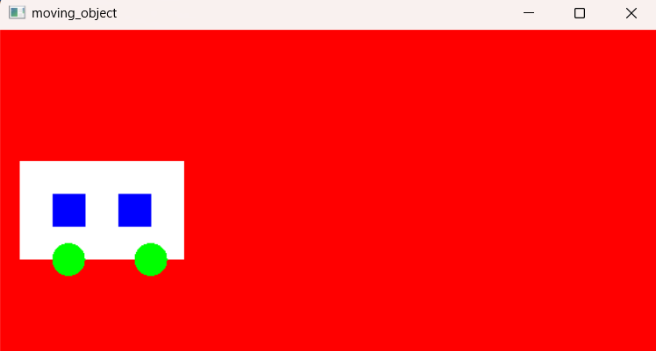
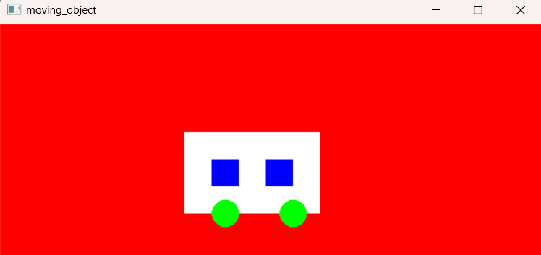
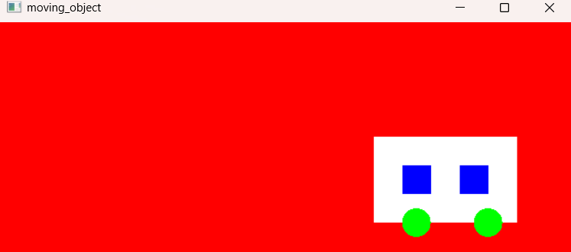
Output

Discussion
In this lab task, I successfully created a bus using basic OpenGL functions. The Scenery was drawn by combining simple shapes such as circles and rectacgles for the wheels, body and body and move all of them. Each part was given a different color using glColor3f() to make the figure more visually clear. The program used glBegin() and glEnd() to define shapes, while glVertex3f() specified their coordinates. Overall, this lab demonstrated how OpenGL can be used to design graphical objects using coordinating geometry & color control.

